Batch: D2 Roll No.: 16010221025

Experiment / assignment / tutorial No. 8

Grade: AA / AB / BB / BC / CC / CD /DD

Signature of the Staff In-charge with date

TITLE: Virtual Lab experiment on Call by reference.

______________________________________________________________________
AIM: Virtual Lab experiment on Call by reference
http://cse02-iiith.vlabs.ac.in/
http://cse02-iiith.vlabs.ac.in/exp8/simulation/CallByReferencePointers/index.html
Program to swap two number without using third variable using Call by reference.
Expected OUTCOME of Experiment:

To get the understanding of how to pass values to the function using call by value and call by reference.

_____________________________________________________________________
Books/ Journals/ Websites referred:

- Programming in C, second edition, Pradeep Dey and Manas Ghosh, Oxford University Press.
- Programming in ANSI C, fifth edition, E Balagurusamy, Tata McGraw Hill.
- Introduction to programming and problem solving , G. Michael Schneider ,Wiley India edition.
- http://cse.iitkgp.ac.in/~rkumar/pds-vlab/

_____________________________________________________________________

Problem Definition:

The call by reference method of passing arguments to a function copies the address of an argument into the formal parameter. Inside the function, the address is used to access the actual argument used in the call.
In the program, a function called swap ( ) is used in which the address is used to access the actual argument.

Implementation details:

Code for Call by Value:

#include<stdio.h>
void main(){
int A = 10;
printf("Value of A is %d\n",A);
printf("Address of A is %d\n",&A);
int *P
P = &A;
printf("Value of P is %d\n",P);
printf("Address of P is %d\n",&P);
printf("Value at the address in P is %d\n",*P);
*P = 20;
printf("New Value of A is %d\n",A);
}

Code for Call by Reference:

#include<stdio.h>
void main(){
int A = 5, B = 9;
printf('Value of A is %d\n',A);
printf('Value of B is %d\n',B);
swap( &A , &B );
printf('Value of A after swapping is %d\n',A);
printf('Value of B after swapping is %d\n',B);
}

void swap( int *Pa , int *Pb){
int temp = *Pa;
*Pa = *Pb;
*Pb = temp;
}

Output(s):

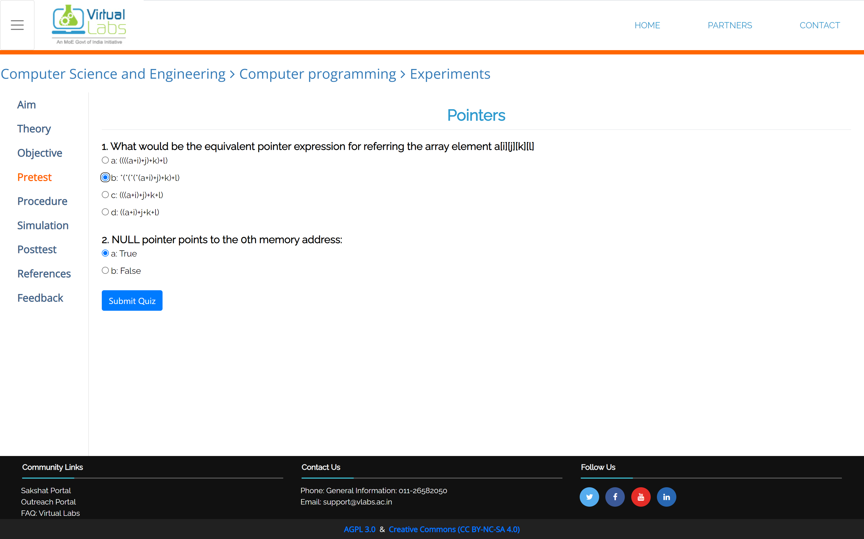

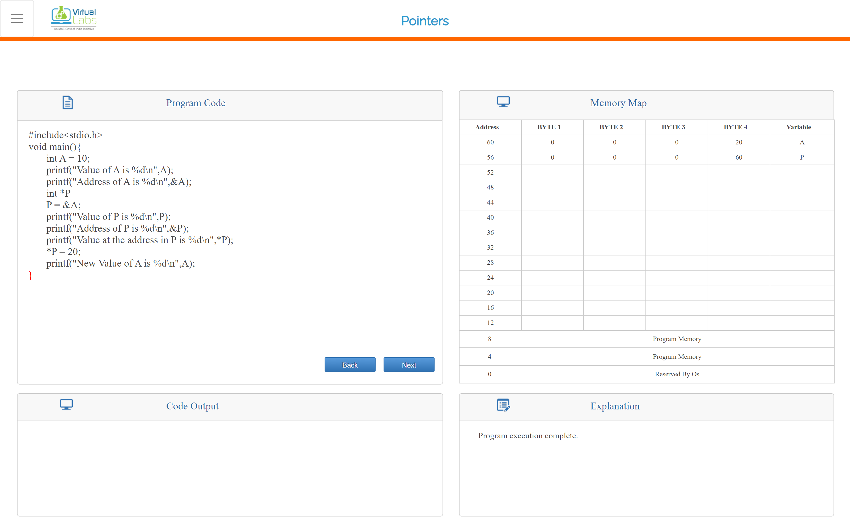

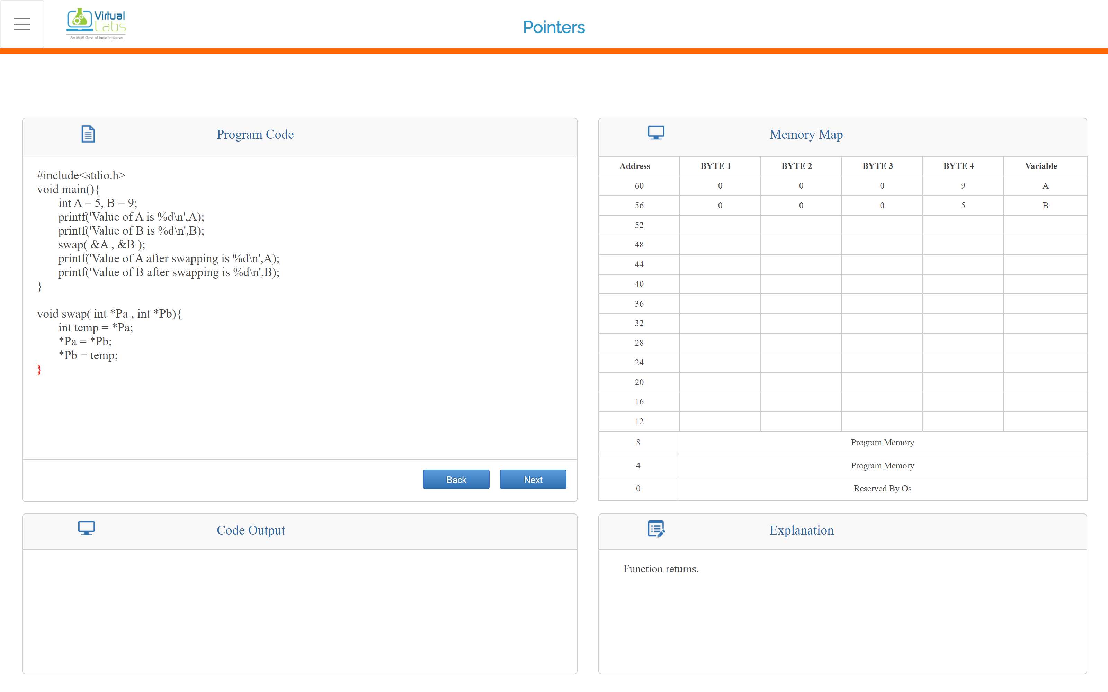

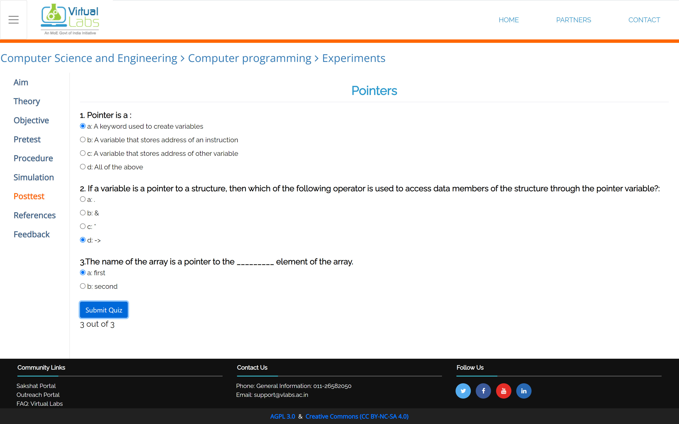

Conclusion:

With the help of simulation on Vlabs, I practiced passing values to the function using Call by value and the call by reference.

Post Lab Descriptive Questions

- Difference between call by value and call by reference in C.

Ans.) Call by Value means directly passing the values of the variable from the function call to the function definition so that any changes made in the formal parameters does not reflect in the actual parameters.
while Call by Reference means trespassing the memory location of the variable from the function call to the function definition so that any changes made in the formal parameters also reflects back into the actual parameters.

- What would be the output of the following program:

void main( )
{
float a = 13.5 ;
float *b, *c ;
b = &a ; /* suppose address of a is 1006 */
c = b ;
printf ( "\n%u %u %u", &a, b, c ) ;
printf ( "\n%f %f %f %f %f", a, *(&a), *&a, *b, *c ) ;
}

Output:
1006 1006 1006
13.5 13.5 13.5 13.5 13.5

Date: _____________ Signature of faculty in-charge

